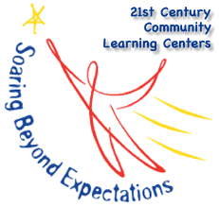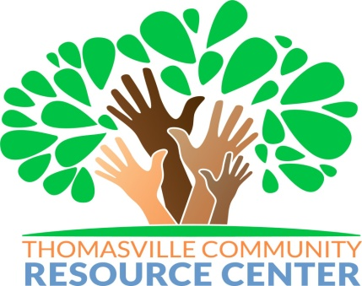
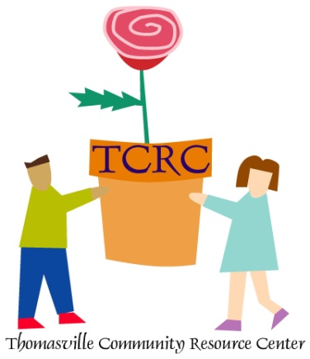
P.O. BOX 1897

THOMASVILLE, GEORGIA 31799-1897

Phone: (229) 226-5846 Fax: (229) 226-4595
Email: lisa.billups@tcrc.community

BID REQUEST FOR EXTERNAL EVALUATOR, 21ST CENTURY COMMUNITY LEARNING CENTERS GRANTS

The Thomasville Community Resource is soliciting bids for a consultant or consultants to perform an external evaluation of the 21st Century Community Learning Centers afterschool program. This person or group will be retained by a contract and must have no invested interest in the 21st CCLC program, including current or past employees of the agency, employee’s family members, partners or participants. The person or group is required to attend 21st CCLC Evaluation Training Sessions with GaDOE and attend local leaders, Advisory Board or Council meetings. Also, must have experience with evaluation practices, educational programs, nonprofit organizations and youth development.
This contracted service provider will:
- Attend one GA DOE sponsored evaluation training, as well as a local training to get access to required data files.
- Visit with program manager and conduct individual site visits that preferably coincide with report card grading periods, at minimum, since this is a good time to review program progress. Talk with students, parents, staff and other stakeholders.
- Collaboratively work with site coordinators and program manager in collecting data and determining program revisions for continuous improvement and use state-provided reporting forms.
- Be trained in 21st CCLC data system. Access data directly from DOE approved data system.
- Complete formative assessments as described in contract and subgrantee Operations Manual and submit to Program Manager in time to be reviewed and returned for revisions prior to Program Director submission to GaDOE.
- Complete the End-of-the-Year Summative Evaluation Report and Common Data Elements worksheet and submit to Program Manager in time to be reviewed and returned for revisions prior to Program Manager submission to GaDOE.
- Complete the Summer Evaluation Report and submit to Program Director for review prior to Program Manager submission to GaDOE.
- Provide clear, honest and relevant recommendations for improvement.

Responses should be emailed on or before August 30, 2021. “EXTERNAL EVALUATOR 21st CCLC” should be included in the subject line. Bids will be opened September 1 at 3:00pm at the Thomasville Community Resource Center, 501 Varnedoe Street, Thomasville, GA 31792. Thomasville Community Resource Center reserves the right to accept or reject any and/or all bids. If you have questions regarding requirements please contact, Lisa K Billups lisa.billups@tcrc.community 229-226-5846 (office).
21st Century Community Learning Center – Evaluation Services
The Thomasville Community Resource Center currently operates three 21st Century Community Learning Center (CCLC) Grant Programs that serve students in the Thomasville City School district as well as the Pelham City School System. These grants were awarded by the Georgia Department of Education through a competitive grant process. The 21st CCLC Program was developed to provide federal funds to local schools and organizations to operate after school programs for the purpose of:
•Providing opportunities for academic enrichment and tutorial services for students
•Offer students a broad array of additional services, programs, and activities to reinforce and complement the regular academic program; and
•Offer families of 21st CCLC students the opportunity for literacy and related educational development
The programs target students who are in need of additional academic assistance. Some of the criteria for students to qualify for available slots includes: academic performance below grade level; not meeting state standards on tests; and/or failing grades in one or more subjects/classes.
Each grant site provides students with a wide variety of after school activities such as academic tutoring, homework assistance, academic enrichment sessions, cultural/fine arts education, technological and character education. The program also provides students with opportunities to participate in field trips and listen to speakers on topics such as life skills, academic motivation, college and career prospects, drug awareness, conflict resolution and violence/gang prevention.
Students receive a daily snack and are provided with transportation home each day. Strong emphasis is placed on intensive academic tutoring, remediation, acceleration, project based learning and enrichment activities. All activities correlate with the Common Core Georgia Performance Standards (CCGPS) to ensure program activities correlate with the school day and meet the individual needs of each participant.

Subgrantee Operations Manual

IX. Effective Data Collection and Program Evaluation
As required by federal statute, 21st CCLC programs must continuously measure the effectiveness of their programs to ensure high quality academic enrichment opportunities and assess the program’s progress towards achieving overall student success. The results of these evaluations should be used to refine, improve and strengthen the overall quality of the program. It is especially critical that programs formalize a detailed plan to ensure access to the data necessary to analyze its progress. (e.g. student grades, assessment scores)

All subgrantees must use an external evaluator to conduct the ongoing evaluation of their programs. An external evaluator is an individual, agency, or organization, with no vested interest in the 21st CCLC program. This requirement refers, but is not limited, to current and former employees of the applicant or co-applicant agency, the original grant application writer(s); family members of employees, participants, and partners; and the applicant’s partners. Contracts with external evaluators must be limited to an individual fiscal year with renewal options for each subsequent year of the grant term. The amount to be paid to the evaluator from grant funds cannot exceed 3% of the annual grant award amount. If the amount to be paid exceeds 3% of the grant award, the outstanding balance must come from other non-21st CCLC sources.

A. Measureable Goals and Objectives

- For each goal, the subgrantee must include specific objectives with accompanying performance measures that are quantitative and challenging, yet achievable.
- Each student-based objective must be performance based and must be able to be continuously measured throughout the year.
- These measurable objectives will be monitored and continuation funding is likely to be dependent on achieving the objectives as proven by data.
- All goals and objectives must be shared with partners, regular school staff, out-of-school staff, parents, evaluator, and students and evidence of sharing is documented through agendas and sign in sheets.
- End-of-the-year results on goals and objectives will be reported in Cayen AfterSchool 21.

B. Progress Monitoring and Formative Evaluations
Each Sub-grantee must undergo periodic (formative) evaluations to assess progress toward achieving the proposed objectives and ultimate goal of providing high-quality opportunities for academic enrichment. The formative evaluations should involve both quantitative and qualitative data collection. The results of the formative evaluations must be:

- Used to refine, improve, and strengthen the program (i.e., continuous improvement of the program)
- Made available to the public upon request
- The format for the formative evaluation is provided by the 21st CCLC department.

The written formative evaluation reports must contain, at minimum, the following elements:
- Student Attendance: Data on average daily attendance and enrollment at each site (Data is maintained in the Cayen System and collected by site managers)
- Program Operation: Synopsis of current level of operation at each site
- Objective Assessment: Data analysis and indication of progress towards
achieving EACH objective (as required, all objectives must include measures that allow for continuous [formative] assessment)
- Recommendations: Recommendations for programmatic refinement for all
objectives where progress is not being achieved or where the program is not likely to achieve the stated objective by the end of the program year

C. CAYEN AfterSchool 21 Data Entry
Cayen Afterschool 21 is the tool utilized by GaDOE to submit data into the USED data collection website. Subgrantees must enter data in Cayen Afterschool 21 on a regular basis.

- All students must be registered into Cayen AfterSchool 21 at the beginning of the program; set up term calendar.
- Georgia Testing Identification (GTID) numbers must be entered for all students.
- Build rosters in Cayen AfterSchool 21.
- Daily attendance must be taken and recorded in a timely manner.
- Grades must be entered for each grading period for English/Language Arts and math (you may enter other subject grades as determined by your program’s goals and objectives).
- Subgrantees are required to distribute teacher surveys and have the option to use Cayen AfterSchool 21 to generate surveys as one tool to assess the effectiveness of the program for their students. The results must be entered into Cayen AfterSchool 21 at the end of the year.
- Data must be certified by the program director for school year program in accordance with the timeline established by GaDOE. Complete Annual Performance Report (APR) Certification Review Report in Cayen AfterSchool 21.

D. Summative Evaluation Requirements
Each 21st CCLC program must submit a summative evaluation report by June 30th. The summative report, which is prepared by the third party evaluator, must provide a detailed summary of the program and progress towards meeting each stated objective. Each report must include, at a minimum, the following major sections:

- Common Data Elements page provided by GaDOE 21st CCLC
- Overview and History
This section must contain a general overview of the subgrantee’s 21st CCLC program, including a history of previous operation and how the program has progressed and grown over the past year(s) of operation, if applicable.
- Student Attendance and Enrollment
  - Student enrollment (per site and for the grant as a whole); enrollment must include overall total enrollment and the number and percentage of regular attendees (attending >30 days).
  - Average daily attendance (per site)
  - Student demographics (e.g., gender, ethnicity)
- Program Operation
The summative report must include information on operation for each site within the program (e.g., days, hours, and weeks of operation for each component).
- Quality of Staffing
The composition of site staff is one method for assessing the quality and breadth of a 21st CCLC program. For each site within the program, the summative report must include information about staffing, such as staff demographics, student to staff ratio, staff training and/or professional learning, and utilization of certified teachers.
- Objective Assessment
Within the grant application, 21st CCLC programs proposed both objectives and methods of evaluating progress towards achieving the objectives. The summative report must include detailed information for each objective approved by GaDOE (e.g., activities, data collected, timeline, analysis, and results). Programs are not permitted to revise, reword, or otherwise change their objectives without specific written approval from GaDOE in the form of a program amendment.
- Other Observations
If appropriate, provide other relevant findings pertaining to the 21st CCLC program. Other findings could include qualitative and/or quantitative data not related to specific objectives; quotes or statements from students, parents, or teachers; success stories of students within the program; and photographs demonstrating unique program activities and services.
- Progress towards Sustainability
The summative report must provide information about the program’s partnerships (e.g., partnership development, partner maintenance, and contributions to the program).
- Overall Recommendations
Provide an overall assessment of the 21st CCLC program, as well as any program-wide recommendations to enhance program quality. This is considered to be the most important section of the Summative Evaluation.

Objectives for the 2021-2022 Year
Thomasville City

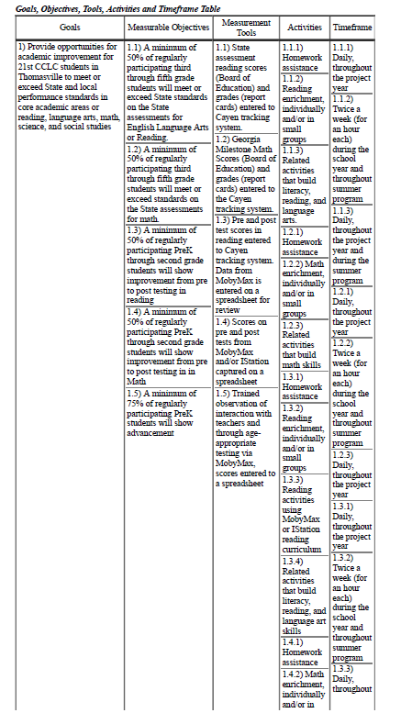

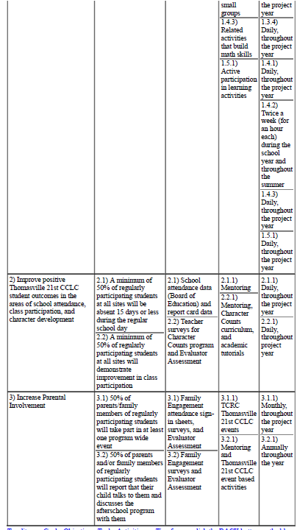

Objectives for the 2021-2022 Year
Mitchell County (Pelham Elementary)

Grant Goals & Objectives
Goal 1: Provide opportunities for academic improvement for 21st CCLC students, so they meet or exceed state and local performance standards in core academic areas of reading, language arts, math, science and social studies.
  - A minimum of 40% of regularly participating 3rd - 8th grade students will meet or exceed state standards on the state assessments for ELA. MEASURE: State Assessment Reading scores, DATA SOURCE: Board of Education grades in school information system, entered into Cayen.
Activities: homework assistance, reading tutorials and Study Island or IStation reading curriculum.
Timeframe: Daily throughout the project year.
  - A minimum of 40% of regularly participating 3rd - 8th grade students will meet or exceed state standards on the state assessments for Math. MEASURE: State Assessments Math scores DATA SOURCE: Board of Education grades in school information system, entered into Cayen.
Activities: homework assistance, math tutorials and Study Island or IStation math curriculum.
Timeframe: Daily throughout the project year.
  - A minimum of 50% of regularly participating 3rd - 8th grade students will maintain or improve their report card grades in Reading as measured from the first 9 weeks to the last 9 weeks. MEAUSURE: Report Card Grades for Reading DATA SOURCE: Board of Education grades in school information system, entered into Cayen.
Activities: homework assistance, reading tutorials and Study Island or IStation reading curriculum.
Timeframe: Daily throughout the project year.
  - A minimum of 50% of regularly participating 3rd - 8th grade students will maintain or improve their report card grades in Math as measured from the first 9 weeks to the last 9 weeks. MEASURE: Report Card Grades for Math DATA SOURCE: Board of Education grades in school information system, entered into Cayen.
Activities: homework assistance, math tutorials and Study Island or IStation math curriculum.
Timeframe: Daily throughout the project year.
  - A minimum of 50% of regularly participating K-2nd grade students will show improvement from pre to post testing in Reading using Study Island and/or IStation Reading Program tool as screening. MEASURE: Scores on Pre and Post Tests DATA SOURCE: Evaluator Assessment of Scores, entered into Cayen.
Activities: homework assistance, reading tutorials and Study Island or IStation reading curriculum.
Timeframe: Daily throughout the project year.
  - A minimum of 50% of regularly participating K-2nd grade students will show improvement from pre to prost testing in Math using assessments from the Study Island and/or IStation Math program tool as screening. MEASURE: Pre and Post Assessments DATA SOURCE: Evaluator Assessment of Scores, entered into Cayen.
Activities: homework assistance, math tutorials and Study Island or IStation math curriculum.
Timeframe: Daily throughout the project year.
Goal 2: Improve positive 21st CCLC student outcomes in the areas of school attendance, class participation and character development.
2.1) A minimum of 40% of regularly participating students (attending 30 days or more) at all sites will be absent 15 days or less during the regular school day. MEASURE: School attendance data DATA Source Board of Education report card data.
Activities: Mentoring Timeframe: Daily throughout the project year.
2.2) A minimum of 40% of regularly participating students (attending 30 days or more) at all sites will demonstrate improvement in class participation. MEASURE: Teacher surveys and biweekly communication between the day school teachers and the after school teachers.
Activities: Homework assistance, math and reading tutorials, and mentoring. Timeframe: Daily throughout the project year
2.3) A minimum of 40% of regularly participating students (attending 30 days or more) at all sites will demonstrate improvement in character development and behavior. Measure: Teacher surveys/Character Counts Program Data Source: Evaluator assessment of information entered into Cayen.
Activities: Mentoring, Academic tutorials, and Character Counts curriculum. Timeframe: Daily throughout project year.
Goal 3: Increase Parental Involvement
3.1) 40% of parents and/or family members of regularly participating students (attending 30 or more operational days) will participate in at least one program wide event. Measure: Family Engagement attendance sign in sheets and surveys. Data Source: Evaluator assessment of information entered into Cayen.
Activities: 21st Century event based activities. Timeframe: Monthly throughout project year.
3.2) 50% of participating students’ parents/guardians will report that their child talks to them/discusses the after school program with them as indicated by annual parent surveys (parent-child engagement). Measure: Parent Surveys Data Source: Evaluator assessment of surveys, entered into Cayen.
Activities: 21st Century event based activities. Timeframe: Monthly throughout project year.

Independent Evaluator Solicitation Questions

Due Date: August 30, 2021

Please review 21st Century Community Learning Center goals and objectives as well as site information prior to completing solicitation responses. Responses should not exceed 5 pages.

- Provide a detailed summary of your experience in writing education related evaluation reports. (15 points)
- Provide a summary of your experience in working with the 21st Century Community Learning Center with emphasis on evaluation. (20 points)
- Provide a timetable of site visits with a minimum of 2 visits per site (More visits if necessary based on the site). The first visit should be on or before the 2nd semester report card distribution and the visits will be outlined in the contract for services. The second visit must be before the 4th semester report card distribution, the visit will also be outlined in the contract for services. (20 points)
- Low cost bidder (5 points)
  - Note: mileage and supply costs should not be included as separate line items in your fee structure. This is a fixed cost contract so all fees must be incorporated in a single cost for each grant you have selected for the duration of the contract.

Please provide credentials or work products that support your experience as an evaluator. Support documents are not included in the maximum 5 pages required for the solicitation response.

Requested Amount to be paid for services Thomasville (See Site list) $________

Requested Amount to be paid for services Grant C (See Site list) $________

Thomasville Site List
Scott Elementary School  404 N Broad St, Thomasville, GA 31792 |  | Harper Elementary School  520 Fletcher St. Thomasville, GA 31792

Grant C Site List
Pelham Elementary School 534 Barrow Ave SW, Pelham, GA 31779

