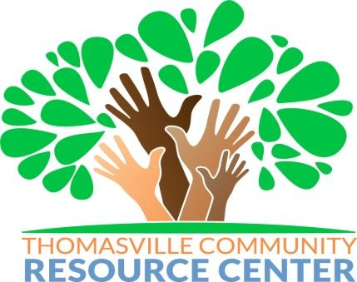
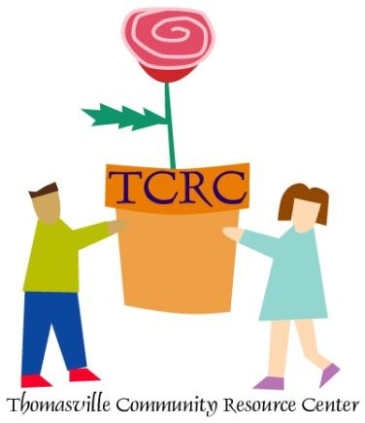
P.O. BOX 1897
THOMASVILLE, GEORGIA 31799-1897
Phone: (229) 226-5846 Fax: (229) 226-4595
Email: tcrc.receptionist@tcrc.community

Thomasville Community Resource Center (TCRC) provides youth afterschool and summer programs using private, state and federal funding. The federal funding includes, but not limited to:
- The Georgia Department of Education, Nita M. Lowey 21st Century Community Learning Centers (21st CCLC) program supports the creation of community learning centers that provide academic enrichment opportunities during non-school time for children, particularly students who attend low-income and low-performing schools. (GADOE 21st CCLC)
- The Afterschool Care Program is located within the Georgia Division of Family & Children Services (DFCS), Well-Being Services Section, and provides federal funding to non-profit organizations and public agencies who serve youth and families during the out-of-school time. The mission of the Afterschool Care Program is to provide resources to youth-serving organizations within the State of Georgia who serve families within low-to-moderate income communities and the foster care system. (DFCS Afterschool)
Out-of-school time (OST) programs should provide a safe environment for academics, particularly for reading, language arts, math, and enrichment. The focus should be on embedded, real-world learning projects. Instructors and activities should be engaging and fun. Think of the students as the customers and respect their time. The programs are optional, not required, so the activities need to be attractive, as well as effective. The purpose of the TCRC programs is to Improve academic achievement and offer enrichment activities designed to reinforce and complement the regular school curriculum. We want to improve academic achievement, but we also want to expose students to enrichment opportunities and activities that normally would not be afforded to them. Enrichment activities also broaden students’ experiences by including, but not limited to, the arts, dance, recreation, poetry and cultural activities.
TCRC provides programs at the following locations for Pre-k through 8th grade students:
- Harper Elementary Thomasville (32 students)
- Scott Elementary Thomasville (65 students)
- Garrison Pilcher Elementary Thomas County (40 students)
- Cross Creek Elementary Thomas County (40 students)
- Thomas County Middle School Thomas County (40 students)
- Pelham Elementary Mitchell County (75 students)
- Varnedoe Street (40 students)

YOUTH DEVELOPMENT/ENRICHMENT & FAMILY ENGAGEMENT SUB-CONTRACTS
Completion and submission of an enrichment contract application constitutes acceptance of all TCRC policies and procedures as well as GADOE 21st CCLC and DFCS Afterschool program guidelines. Subcontractors agree to abide by the results of the selection process. Contractor selection is based on the community need and available funding.

ELIGIBLE SUB-CONTRACT APPLICANTS
Eligible applicants may include individuals, faith based organizations, institutions of higher education, city or county government agencies, for-profit corporations and other public or private entities. Successful applicants must demonstrate experience in providing educational and related activities that will complement and enhance the academic performance, achievement and positive youth development of students.

GRANT ASSURANCES
Completion and submission of an enrichment contract application constitutes acceptance of all identified assurances, agreements, and guidelines of TCRC, the GA-DOE 21st CCLC program and the DFCS Afterschool program. Contractors agree to abide by the results of the selection process.

COMPETITIVE PRIORITY
All applications will be assessed competitively according to the scoring rubric criteria. Priority will be afforded to those providers with experience working with at-risk elementary school students.

DUE DATE AND TECHNICAL ASSISTANCE
All proposals must be emailed on or before 5:00 p.m. on August 23, 2021 to tcrc.receptionist@tcrc.community. Technical Assistance (T/A) will be available from August 10-13, 2021. All T/A questions must be submitted to tcrc.receptionist@tcrc.community. Only written questions will be accepted and no questions will be allowed after 5:00 p.m. on August 13, 2021. All T/A responses will be uploaded to the TCRC website http://www.tcrconline.org/employment.aspx

P.O. BOX 1897
THOMASVILLE, GEORGIA 31799-1897
Phone: (229) 226-5846 Fax: (229) 226-4595
Email: tcrc.receptionist@tcrc.community
PROPOSAL QUESTIONS
- Organization / Individual address, city, state, zip code, county, phone number and email. (5 points)
- Provide a brief summary of credentials, certifications, experience or training you have received in the specific enrichment areas you are submitting in your proposal. (15 points)
- How long have you provided services to at-risk children? (10 points)
- Are you a provider based in South Georgia with a South Georgia address? (5 points)
- Are you currently providing services to youth in South Georgia? (5 points)
- Requested hourly amount to be paid for services $___________ (Lowest rate 3-point bonus)
- Describe the services you provide and how the services will benefit the target population. Provide a summary of your experience working with at risk youth in athletic, character development, health or STEAM related enrichment programs. Be specific when outlining activities and tasks working directly with at-risk youth. (25 points)
  - Targeted population is defined as children from age 2 – 14
  - Athletic (including but not limited to): Football, Basketball, Tennis, Golf, Track and Field.
  - Health (including but not limited to): Physical Fitness Activities, Mental Health, Food and Nutrition
  - STEAM: Science Technology, Engineering, Arts (Visual and Performing), and Math
  - Character development
- Describe how you will maintain interest in your activities and services for the target population. (10 points)
LIST THE SITES YOU PLAN TO PROVIDE SERVICES IN YOUR NARRATIVE.
ONTRACTOR SCHEDULE WITH PAYMENT WILL BE INCLUDED IN CONTRACT (AFTER PROPOSAL REVIEW AND SELECTION).
ALL CONTRACTOR STAFF WORKING WITH STUDENTS MUST PASS A COMPREHENSIVE BACKGROUND SCREEN AND COMPLETE A DRUG TEST.

